How will the engineering team program the speaker without the help of single board computer?

No, that is still the same I didn’t show the details in here. EE group uses single board computer to receive signals. EE students don’t do anything extra here, they scan for signals and play the sound as proposed earlier.

Can you please clarify what did you mean by BLE signals from server? Servers mainly deal with data, not BLE signal.

BLE signal is actually sent from the users’ cellphone. ‘But when it is done’ that calculation is done by the server (or you can use app to do this calculation). Conditions: when user is within 5m range of the bus stop and bus is 200m away from the stop. Only disabled person’s cellphone.

As per discussion with Reza, the engineering with the Engineering team will deal with single board computer programming. Please note that it will be too much workload for the COSC team to create another app to track the bus location. We could use the same user app to track the bus location, but it will require major changes on our database side and will make the project more complex. Even if we do it, how will the engineering team will program the light sensor system without single board computer? Based on our initial architecture, we were planning to get the bus location from location engine.

Just to clarify, light sensor system is still the same (nothing has changed as proposed earlier.) Could you explain, how you plan to track the bus? Location engine?.......If this will add more work for COSC students, I would suggest EE students to add a GPS tracking board to light sensor system plus an LTE module for internet. (Fremtid media will provide additional Micro/Nano SIM with enough data to sync data with server). COMS students can program these two additional boards to send the collected information to their server and rest remains the same.  
Wasek- Location Engine: Web panel/APIs that allow to access the data (beacon location, health, etc.) that gateway transmits. Gateway scans for beacons in range and sends the info to the location engine (i.e. web panel or Kontakt server) using wifi. That being said, Gateway requires power and internet connection. It can be set up in the following way (plz see the figure).   
  
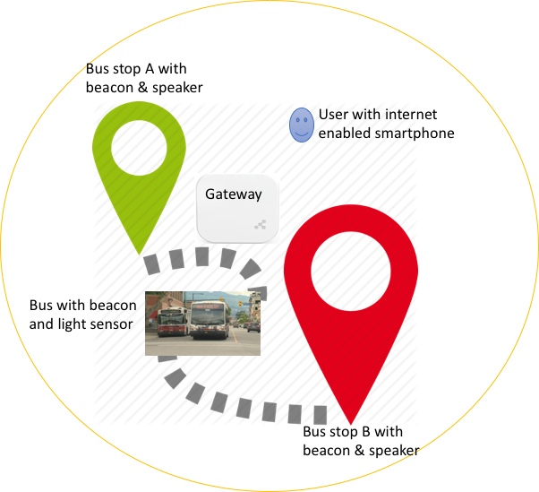

Note:

1. Bus stops have beacons, LTE enabled computers, and speakers
2. Buses have beacons, LTE enabled computers, and light sensors
3. The circle is the gateway range and gateway can be placed in somewhere in the middle of two bus stops. EE team is responsible for placing and configuring the gateway and beacons so I will leave it to them to place the gateway in an optimum location.

I have submitted a ticket to Kontakt.io to make sure that we will be able to get the bus location from the location engine. I will keep you posted.   
  
Beacons are used where GPS fails. Beacons and GPS are substitutable technology. I am not sure if we use a separate GPS tracking board, what is the point of using beacons? We are using the user location using GPS anyway, same thing can be done with the bus.

Programming the computers is out of our scope as per our discussion with Reza:

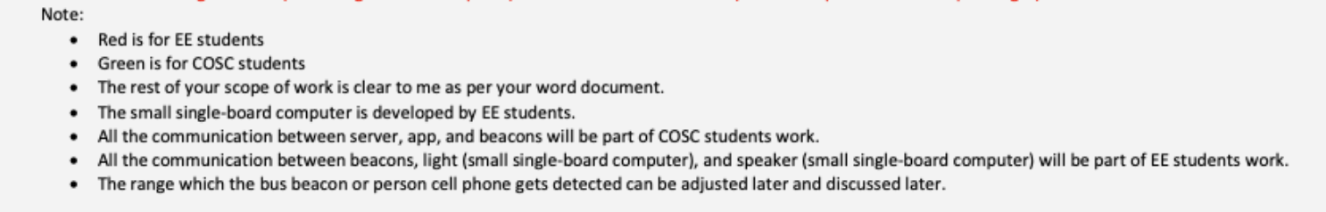

Beacons can only send their IDs and location data. How can it tell the light sensor to work?

A notification is sent to the cellphone users when they are on the bus. (Decrease the range of this beacon so that the users outside of the bus don’t get this notification.) Now this notification/signal is forwarded to the server from the user’s app and then sent to light sensor system. This only happen for disable person, regular users only get the message “You are onboard”.

Wasek- We were under the impression that we only have 1 type of user (name it regular/physically impaired) in the project based on our conversation with Reza (plz refer to #11- <https://docs.google.com/document/d/1YCFWMya0rXYs0TlT927PfS1knvyMSKo7bu0vK5TzTlQ/edit#heading=h.qy0o56x5rrlc>)

And there were only three types of notifications:

1. Notification to the user about the bus arrival
2. Notification to the computer at the bus stop about the bus arrival, which will be played by the speaker.
3. Notification to the computer on the bus about the passenger waiting at an upcoming bus stop, which will be displayed through the light sensor.

That being said, we did not plan anything for a separate user type and separate notification for them (i.e. physically impaired people) while we designed our database and application.

I am not sure if Kyle had shared our design doc (<https://docs.google.com/document/d/1ECNqmx5S6KqGPSlo12p9PhH2Gylq8uiLTNykV0q3bXI/edit?usp=sharing>) and presentation (<https://docs.google.com/presentation/d/1sTKD-itjSl7wRyGjODUNL8W3DtK30MG-oYLy5F_4Y68/edit#slide=id.g46f3a14502_1_1076>) with you, but if you look at the contents, you could tell we have already invested significant amount of time on designing our project based on our conversations and previously proposed architecture by the COSC team. Considering the amount of time we invested in the project already, it’s pretty frustrating for the COSC team to see the change of requirements frequently as we have hard deadlines to maintain.